

Tour with the trekking bike through Southern Thailand

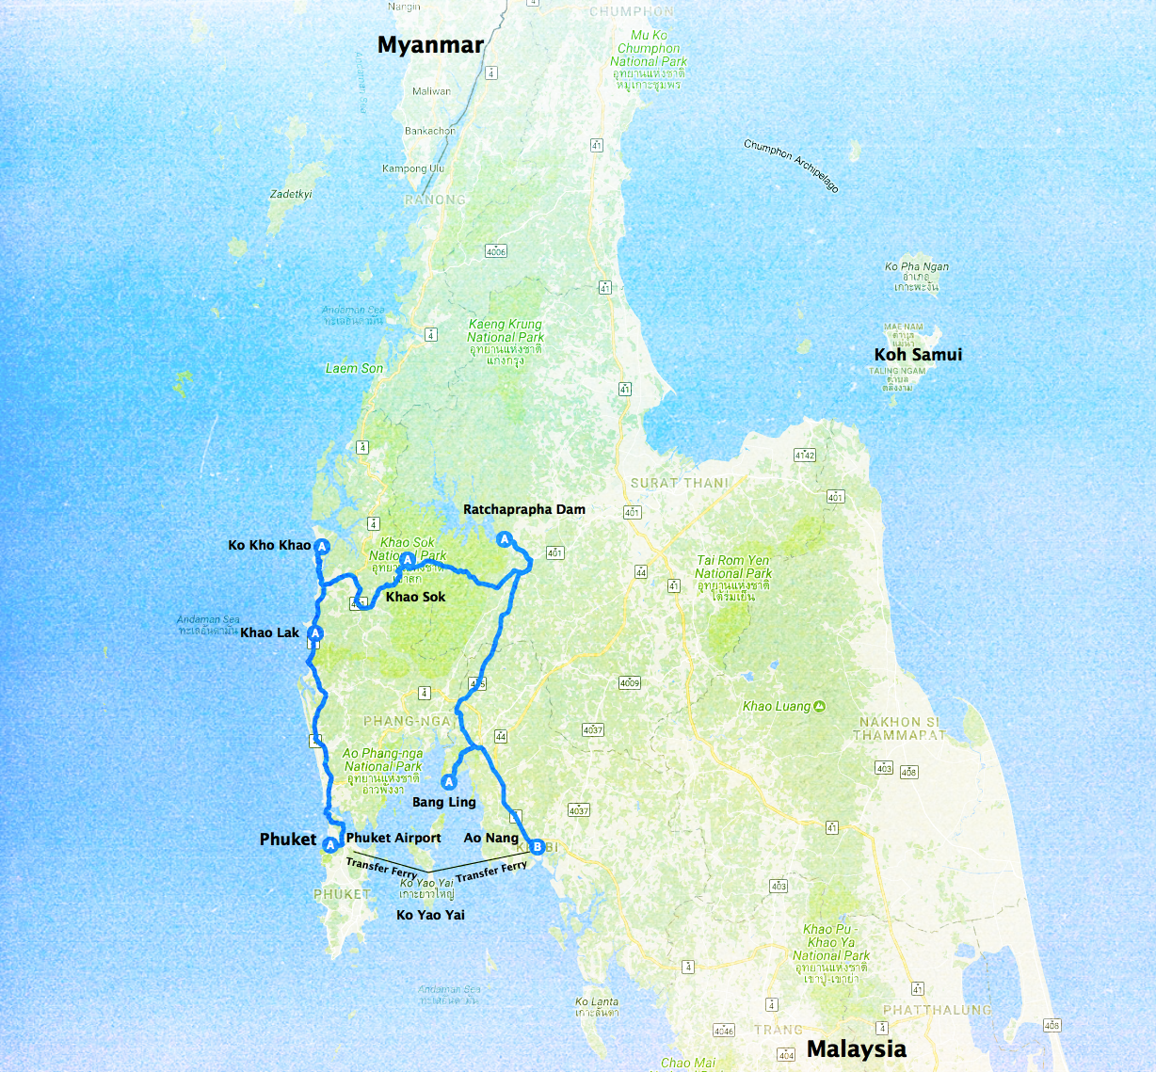

Highlights

* Varied cycling tours through the cone karst landscape of Southern Thailand.
* Beautiful beaches on the Andaman Sea
* Flora and fauna in the rainforests of Khao Sok National Park
* Floating huts on the Ratchaprapha Reservoir
* Two beach days on Koh Yao Yai at the end of the trip

**The tour lasts 12 days / 11 nights and leads over a distance of 327 kilometers.**

**Itinerary:**

This bike tour through the southwest of Thailand leads from the island of Phuket along the Andaman Sea to the north. Great coastlines and beautiful white beaches accompany us on the bike trip. Inland, our bike tour takes us through lush, exotic vegetation, passing through the karst cliffs of Phang Nga Bay and past interesting Buddhist temples. In between, we have plenty of time to relax on the beach or for individual activities such as a long tail boat trip to the floating huts.

**Day 1. Phuket, Nai Yang Beach Resort**

Arrival on Phuket.

Upon arrival, transfer to the resort on a small nice beach off the beaten track. The rest of the day is at leisure. 2 nights at Nai Yang Beach Resort.

|  |  |
| --- | --- |
| Macintosh HD:Users:lucienkirch:Desktop:top picture:South Thailand Trekking:Small Size:IMG_9353.jpeg | Macintosh HD:Users:lucienkirch:Desktop:top picture:South Thailand Trekking:Small Size:NaiYangBeachResort.jpeg |

**Day 2. Khao Lak, Baan Khao Lak Beach Resort (B, L)**

Along the Andaman coast to Khao Lak

we start our today's bike ride from the hotel on quit rubber plantation roads to the Sarasin Bridge, which connects the island of Phuket with the mainland. It goes north along the coast to the Khao Lak Lam Ru National Park, which reaches up to the rugged coast. For the last 30 km we will transfer you to the hotel in Khao Lak 1 night in Khao Lak, The Waters Resort (about 45km). 200 Climbing Meters

|  |  |
| --- | --- |
| Macintosh HD:Users:lucienkirch:Desktop:top picture:Bangkok - Phuket:Bangkok - Phuket Traveldocuments pics:small:Piertophuket.jpeg | Macintosh HD:Users:lucienkirch:Desktop:top picture:South Thailand Trekking:Small Size:BaanKhaolakbeachresort2.jpeg |

**Day 3. Ko Kho Khao, The Sunset Beach Resort (B)**

Across to Ko Kho Khao

We continue our cycling trip to Ko Kho Khao Island. We are accompanied by a varied landscape. A highlight of the day is the beautiful ferry crossing over to the island, whose east side is covered by mangrove forests. 1 night at C+N Resort (45km). 200 Climbing Meters

|  |  |
| --- | --- |
| Macintosh HD:Users:lucienkirch:Desktop:top picture:South Thailand Trekking:Original Size:26166873_850308928470705_403142282811543871_n.jpg | Macintosh HD:Users:lucienkirch:Desktop:top picture:South Thailand Trekking:Small Size:SunsetBeachResort.jpeg |

**Day 4. Khao Sok, National Park Our Jungle House (B, L, D)**

In the jungles of the national park Khao Sok

Back on the mainland, we leave the coastal region and head to the hilly, primeval hinterland covered by rainforests. At noon, we reach the Khao Sok National Park, which is known for its diverse flora and fauna. But the landscape is also impressive: Again and again you can see white limestone cliffs and rugged cut valleys. We spend the night in a simple lodge on the edge of the national park. 1 night at Our Jungle House (70km). 500 Climbing Meters

|  |  |
| --- | --- |
| Macintosh HD:Users:lucienkirch:Desktop:top picture:South Thailand Trekking:Original Size:26195676_850308731804058_3768105417737728153_n.jpg | Macintosh HD:Users:lucienkirch:Desktop:top picture:South Thailand Trekking:Small Size:our-jungle-houseResort.jpeg |

**Day 5. Khao Sok, National Park Our Jungle House (B, D)**

In the morning, take part in a walking tour through the Khao Sok National Park. The afternoon is at leisure.

|  |  |
| --- | --- |
| Macintosh HD:Users:lucienkirch:Desktop:top picture:South Thailand Trekking:Small Size:trekkingkhaosoknationalpark.jpeg | Macintosh HD:Users:lucienkirch:Desktop:top picture:South Thailand Trekking:Small Size:Our_Jungle_house.jpeg |

**Day 6. Ratchaprapha Dam, Rafthouse on the lake (B, L, D))**

Drive to the Ratchaprapha dam

A new day, a new experience during your bike tour through Thailand. Longboat to the floating huts of Cheow Lan Lake.

Our minibus takes us up to 20 km in front of the Ratchaprapha dam. From there, we bike 20 kilometers over a small road to the reservoir. Here we climb on a boat, which brings us to our current destination, a small settlement with floating huts in the lake (1 night). The drive on the lonely, winding lake is impressive. The day at the lake is at leisure. We swim in the lake or can use the small canoes to explore the lake. In the evening, we take a boat trip to see the wildlife at the lake at dusk. (20 km) 220 Climbing Meters.

|  |  |
| --- | --- |
| Macintosh HD:Users:lucienkirch:Desktop:top picture:Bangkok - Phuket:Bangkok - Phuket Traveldocuments pics:Small Ostküste:IMG_7473.jpeg | Macintosh HD:Users:lucienkirch:Desktop:top picture:South Thailand Trekking:Small Size:Ratchapraphadam.jpeg |

**Day 7. Bangling Homestay (B, L, D))**

Through the original hinterland

We leave the beautiful lake landscape again by boat and climb the dam again on our wheels. On small, scenic roads we pedal south along the Klong Phanom National Park to the temple complex of Wat Bang Riang, which is considered one of the most beautiful in southern Thailand. A short bus ride takes us almost to the coast of the Phang-Na Bay, known for the steeply protruding from the water Cone Karst Rock (James Bond Rock). 1 night in a simple homestay in a small fishing village on the island of Bang Ling. (About 62km) 350 Climbing Meters

|  |  |
| --- | --- |
| Macintosh HD:Users:lucienkirch:Desktop:top picture:Bangkok - Phuket:Bangkok - Phuket Traveldocuments pics:Small Ostküste:IMG_5929.jpeg | Macintosh HD:Users:lucienkirch:Desktop:top picture:South Thailand Trekking:Original Size:wat-bang-riang-temple.jpg |

**Day 8. Ao Nang Hula Hula Resort (B, L, D)**

Cone karst landscapes and mangroves

Today's stage is dominated by the famous cone karst landscapes of the region. It is flatter, the routes but not boring! We approach the mangroves and stop for lunch at a crystal-clear tributary that comes out of the swamps and flows into Phang Nga Bay a few miles further. In the afternoon, continue by bike to the beach of Ao Nang, our starting point for the next days. 2 nights at Hotel Silver Orchid (about 65km) 417 Climbing Meters.

|  |  |
| --- | --- |
| Macintosh HD:Users:lucienkirch:Desktop:top picture:South Thailand Trekking:Small Size:IMG_1160.jpeg | Macintosh HD:Users:lucienkirch:Desktop:top picture:South Thailand Trekking:Small Size:Hula Hula Resort Ao Nang.jpeg |

**Day 9. Ao Nang Hula Hula Resort (B, L)**

In the morning, we take a trip and climb the 1,237 steps up to the shrine of the Tiger Cave Temple. Lunch is at leisure. Relax on the beach and enjoy the beautiful scenery or (optional boat ride Railey Beach and surrounding area). After lunch end of the guiding tour.

|  |  |
| --- | --- |
| Macintosh HD:Users:lucienkirch:Desktop:top picture:South Thailand Trekking:Small Size:Ao_Nag_Beach.jpg | Macintosh HD:Users:lucienkirch:Desktop:top picture:South Thailand Trekking:Small Size:Hula-Hula-Ao Nang.jpeg |

**Day 10. Ko Yao Yai, Baan Taranya Koh Yao Yai Resort (B)**

Beach days on Ko Yao Yai. Here ends the guided tour.

We spend the two final days of cycling holidays on the island of Ko Yao Yai in the middle of Phang Nga Bay. We take the morning ferry to the island and are picked up at the ferry station and driven to the family-run beach hotel. If you do not just want to relax on the beach, you can optionally take a snorkel trip or visit the neighboring mountainous twin island Ko Yao Noi by ferry. The diversity of the underwater world is impressive!

|  |  |
| --- | --- |
| Macintosh HD:Users:lucienkirch:Desktop:top picture:South Thailand Trekking:Small Size:Koh-Yao-Yai-beach.jpeg | Macintosh HD:Users:lucienkirch:Desktop:top picture:South Thailand Trekking:Small Size:BaanTaranyaresort.jpeg |

**Day 11. Ko Yao Yai, Baan Taranya Koh Yao Yai Resort (B)**

Free day to relax.

**Day 12. Transfer to the airport (B)**

Group Transfer at 11 am to Phuket airport and individual return flight. Today it's time to say goodbye. With the small ferry back to the island of Phuket. From there, it's about an hour's drive to the airport.

***(B = Breakfast, L = Lunch, D = Dinner))***

**Included:**

* 11 nights: 9 x in a 3 & 4 Stars Hotel, 1 x in Raft House 2 by rafthouse and 1 x Homestay
* 11 breakfasts
* 4 dinner and 5 lunch
* Fruits, snacks, isotonic drinks
* Thailand Cycle Tours jersey and drinking bottle
* Thailand Cycle Tours Team
* Thai bike guide
* Extra team leader from 6 persons
* Minibus and radio assistance
* Excursions according to the program
* Travel insurance during the tour
* Mountain/Hybride bike rental
* Transfer Phuket airport – Nai Yang Beach Hotel
* Group transfer at 11 am Koh Yao Yai – Phuket Airport

**Optional Extras:**

* Supplement night in Phuket or Kho Yao Yai
* E-Bike Rental
* Tips for guides

Thailand Cycle Tours

Ls Sport Thailand Co. LTD

551 Moo 1 Hin lek fai, Hua Hin , Prachuap Khiri Khan 77110

Email : [info@thailandcycletours.com](mailto:info@thailandcycletours.com)

Tel : +66(0) 632 5678 01

Tel : +66(0) 632 5678 02